An Analysis of the Structural Equation Modeling Influencing the Active Three Ps-Based English Language Teaching

Kamontus Chawna*, Boonchom Sudjit, Ingkayut Poolsub
Corresponding Author E-mail: boonchom_su@rmutto.ac.th

Received: 2025-07-04; Revised: 2025-09-24; Accepted: 2025-09-26

Abstract
The objectives of this study were 1) to find out the factors that influence the use of the Active 3Ps teaching method in teaching English and 2) to analyze the structural equation model of English subjects with the Active 3Ps teaching model using the Structural Equation Modeling technique. The study was conducted with a specific sample of 300 people, and the data were collected and recorded in SPSS. Then, the data were analysis using Structural Equation Modeling (SEM) with the AMOS program to identify the relationship between factors influencing the use of the Active 3Ps-based English language teaching methodology, including measures of student engagement, English speaking skills, and learning satisfaction. The results showed that:
1) there were 2 latent variables and 12 observable variables, with an average of 4.05 and a standard deviation of 0.84, which was a high level, and 2) the results of the structural equation model analysis are consistent with the empirical data with statistical significance with a p-value of .07, the Goodness of Fit Index (GFI) was .992, the Comparative Fit Index (CFI) was .998, which was more than the specified threshold, indicating that the model was well consistent, and the Root Mean Square Error of Approximation (RMSEA) was .05, indicating that the model was very well consistent.

Keywords: Active Learning, Structural Equation Modeling, English Language Teaching, Three Ps Approach

Introduction
As we all know, English has been an important language in education and work for a long time from the past to the present. From the study, it was found that Thai people have problems learning English and using English in everyday life in all 4 skills: listening, speaking, reading and writing, at a very high level. The most common problem is the problem of listening skills in English to understand the meaning, including greeting each other, introducing oneself in everyday life, giving directions, including general daily conversation, speaking to express opinions, making invitations, and using English to present work in front of the class (Pachontarapak et al., 2021).
Teaching English is a very important process in the education system because English is the universal language used for international communication. Therefore, the development of English skills of students in Thailand is the main goal that teachers want to achieve. Teachers must consider of selecting teaching methods that emphasize learners to practice using the new language sufficiently so that learners can interact with their peers and connect their fluency in using the language (Namwong, O. 2011). One of the most popular methods today is the Active 3Ps-based English language teaching model, which consists of Presentation, Practice and Production. This teaching style focuses on actively engaging students in the learning process to strengthen their language skills in depth (Brown. 2007).
Baker, & Westrup (2000) stated that the use of the PPP framework is very flexible. Teachers can use the framework to plan a series of PPP lessons. In addition, teachers can divide the teaching time into different phases, such as one phase is for students to present new language, another phase is for students to use different types of practice activities, and one or more phases are for producing new language. Extending this method of teaching is the most useful when the lesson is only 30 or 40 minutes long. Learners who already know English and want to improve their fluency will need to practice without teacher supervision, but they can benefit from longer production lessons. As mentioned, the PPP framework is useful for planning lessons that introduce new vocabulary, grammar, or language usage. In a PPP lesson, learners use all four language skills: speaking, reading, writing, and listening to practice the new language. Therefore, in a PPP lesson, teachers can focus on the skills in conjunction with the language practice. This way, language skills are built into the activities in the lessons, and the language skills reinforce each other. However, teachers may want or need to give students more time to focus on improving the learners' four skills.
Namwong (2011) concluded that teaching based on the Active 3Ps framework is a useful teaching method for teachers to use in teaching new vocabularies to learners, including language functions in receptive skills, which are listening and reading skills, and productive skills, which are speaking and writing skills. Teaching based on communicative teaching method is a teaching method that focuses on learners as the center. However, the implementation of the Active 3Ps-based English language teaching model in the English classroom requires many factors that influence the success of teaching, one of which is the use of Structural Equation Modeling to analyze the various factors that influence English teaching with this model. The purpose of this study was to study and identify the important factors influencing the teaching of English subjects using the Active 3Ps-based English language teaching model by using structural equations modelling as an analytical tool (Kline, R. B. 2023).
Cha, & Yang (2022) emphasized solving problems and enhancing efficiency in high school English education in China. Their study proposed the use of B/S and MVC structures to support English learning in higher education, particularly focusing on real-time interactive engagement with non-English-major students. The findings revealed that students who used this system achieved significantly higher writing scores compared to traditional methods. These results confirm that the real-time interactive teaching model can effectively enhance students’ writing proficiency and accelerate their overall learning outcomes.
From the book Partial Least Squares Structural Equation Modeling (PLS-SEM), the statistical techniques used to analyze the relationships among latent variables are explained. The book introduces the fundamental principles of PLS-SEM, including the concept of the path model, and clarifies how it differs from Covariance-Based SEM (CB-SEM). In addition, it provides practical guidelines for applying R and RStudio software with the SEM in R package to assess model quality, with a particular focus on evaluating reflective measurement models. Both reflective and formative constructs are discussed, along with the analysis of direct and indirect effects, as well as the evaluation of explanatory and predictive power of the model. In line with the analysis conducted in this research, PLS-SEM was applied to identify primary variables and observable indicators, enabling researchers to determine influencing factors more efficiently. This approach also facilitates a clearer understanding and interpretation of the results. (Hair, Jr. et al., 2021)
Therefore, it enables researchers to understand the process of identifying factors that influence teaching and learning development (Hmimou et al., 2021), as well as to recognize the contributions of Cha, & Yang (2022, December), who examined the effectiveness of applying information technology in English language learning. These perspectives provide relevant dimensions for further research aimed at enhancing instructional practices and improving student learning outcomes.

Research Objectives
1. To find out the factors that influence the use of the Active 3Ps teaching method in teaching English.
2. To analyze the structural equation model of English subjects with the Active 3Ps teaching model using the Structural Equation Modeling technique.

Literature Review
Active Learning
A study was conducted to explore the use of creative teaching strategies aimed at managing anxiety in mathematics and enhancing learners’ mathematical abilities. The primary objective was to assess students’ achievement levels in mathematics both before and after being taught using the Active 3Ps-based English language teaching model. This model, which includes the strategies Perpend, Pair, and Partake, encourages group activities where learners collaborate to solve mathematical problems. By pairing students with varying levels of mathematical ability, the approach promotes peer-supported learning. The findings revealed a significant improvement in the achievement scores of students taught with the Active 3Ps strategy compared to those who were not. These results were measured using a researcher-developed questionnaire, which had an accuracy index of 4.67 and a KR20 reliability index of 0.90 (Zhang, X. 2019).
From the research, the techniques for applying the 3Ps strategy to the teaching and learning in the subject are known to be applied more effectively.
English Language Teaching
A study has found that English language proficiency is crucial for academic success and employment in Vietnam, particularly in industries with foreign investment, which drives global integration. The objective of the research was to investigate the various factors influencing the effectiveness of English education in higher education. Teaching methods, such as communication-focused language instruction, computer-assisted language learning to enhance motivation, and an emphasis on interactive activities, were identified as key strategies for improving English language education and fostering further development (Tran, T. T. 2013).
A study was conducted on the use of information and communication technology (ICT) in teaching English as a Second Language (ESL). ICT allows learners to access a wide range of modern learning resources and helps create an interactive learning environment. This, in turn, increases learners' interest and engagement in the teaching and learning process (Maitlo et al., 2024).
The discussion highlights the challenges in teaching English, specifically the ongoing lack of effective teaching methods for developing language skills, particularly speaking skills, which many students find difficult to master. Additionally, teachers face difficulties in creating a learning environment that encourages engagement and interaction among students (Brown, H. D. 2007).
This study examines the impact of Project-Based Learning (PBL) on students’ engagement in English learning within a virtual environment. The findings reveal that students exhibited greater cognitive engagement through self-directed learning and critical thinking, as well as behavioral engagement through collaboration and project presentations, while also developing a positive attitude toward technology use. Additionally, students experienced increased emotional engagement, reporting enhanced self-confidence from video creation and online presentations. The PBL approach significantly promotes student engagement across cognitive, behavioral, and emotional dimensions (Asfihana et al., 2024).
The study examined the use of Philippine English (PE) in student publications, focusing on the perspectives of English teachers regarding the acceptance of PE in academic writing. Results showed that certain PE lexical features, such as “Fab Lab” and “U-Days,” were widely accepted by English teachers, while others like “blastful” and “sophomostrial” faced high rejection rates. The research underscores the growing legitimacy of PE in written communication and highlights the need for inclusive language teaching practices that reflect the linguistic diversity of the Philippines (Flores, R. A. 2024).
Structural Equation Modeling
The book Principles and Practice of Structural Equation Modeling explains the key concepts and practices of structural equation modeling, a statistical technique used to test and develop theoretical models. This method enables researchers to analyze relationships between observed variables and latent (unseen) variables. In this study, the method was applied to examine factors influencing teaching quality, with the goal of evaluating and improving teaching models (Kline, R. B. 2023).
The results obtained from using the Structural Equation Modeling proach allowed for a clearer understanding of the relationships between various factors influencing teaching quality. By analyzing both observed and latent variables, the study was able to identify key determinants of effective teaching models. This led to more accurate evaluations of teaching strategies and provided insights for improving educational practices.
This research discusses Structural Equation Models and the treatment of correlated errors, which are often overlooked in traditional SEM computations. The researchers identified limitations in existing methods, particularly in handling the correlation between error terms. They proposed an improvement to the iterative method to address correlated errors in recursive models. This revised algorithm provides more accurate covariance matrix calculations, improving the precision of SEM analysis. The study enhances understanding of how correlated error terms affect model estimation and offers a solution for more accurate modeling (Hmimou et al., 2021).
The results indicated that addressing the lack of effective teaching methods is essential for improving students’ speaking skills in English. By identifying and implementing more effective strategies, educators can enhance language development. Furthermore, fostering a learning environment that promotes engagement and interaction among students can lead to better participation and collaboration, ultimately improving overall language proficiency and confidence in speaking skills.

Techniques used
Brown (2007) research presents a teaching technique called “Teaching by Principles”. It emphasizes the use of methods based on principles that have been researched and experimented. The techniques used include creating a learning atmosphere that encourages student participation. The use of communication-oriented activities and the provision of opportunities for students to practice and improve their speaking skills in a variety of situations.

Results of the study
The results of using principled teaching techniques showed that students who were taught with this method improved their speech and language skills. In addition, it has been found that creating a learning environment that emphasizes student interaction and engagement increases learning satisfaction and allows for more effective learning. (Brown. 2007).

Research framework
The conceptual framework for this study is based on the Active 3Ps teaching method, which focuses on three key components: Presentation, Practice, and Production. The framework explores how factors such as student engagement, English speaking skills, and learning satisfaction influence the effectiveness of the Active 3Ps method in teaching English. The study uses Structural Equation Modeling to analyze the relationships between these factors and their impact on the teaching outcomes, aiming to provide a better understanding of how the Active 3Ps approach can enhance language learning as shown in Figure 1.
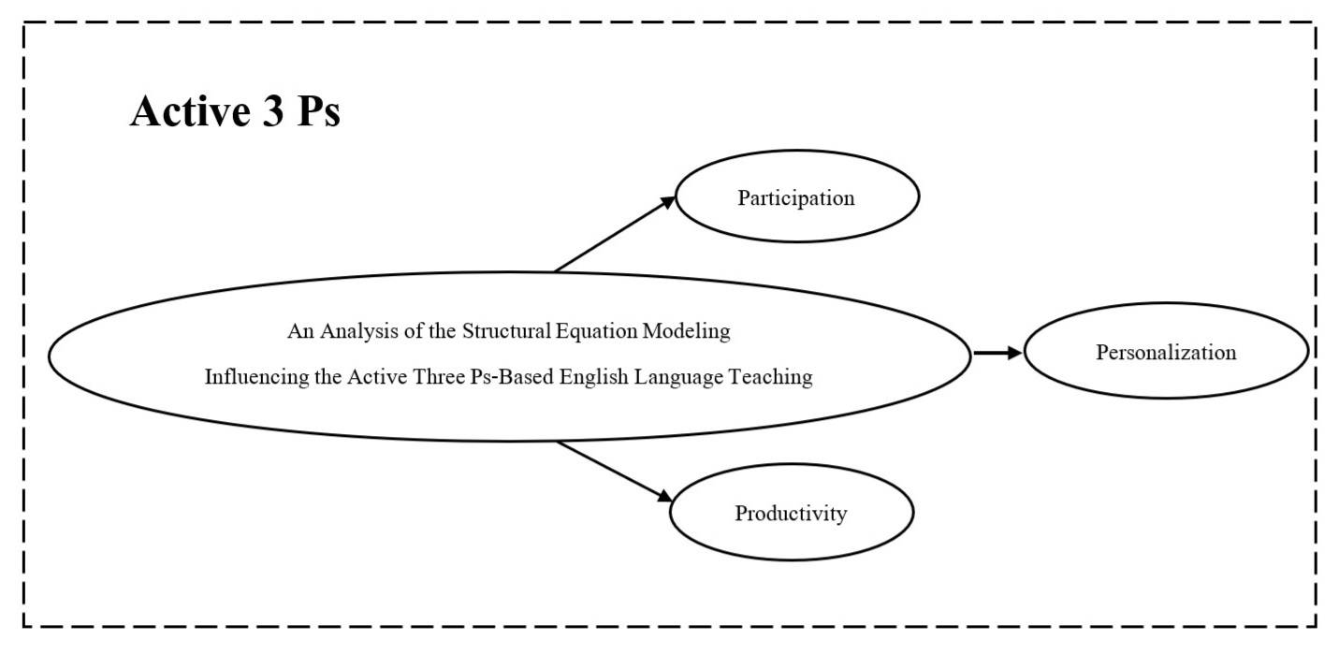
Figure 1 Conceptual Framework of An Analysis of the Structural Equation Modeling Influencing the Active Three Ps-Based English Language Teaching
Research Methodology
This research is a quantitative research that requires an analysis of all dimensions related to variables and uses statistical methods with the AMOS program to help analyze the results according to the following research algorithms:
1. Research Design: Conduct a study using quantitative research design. Structural Equation Modeling was used to analyze the relationship between various factors and the effectiveness of the Active 3Ps teaching method.
2. Sample Selection: The sample consists of A. Experts and B. Students using an online questionnaire with a specific sample of about 300 people to ensure statistical accuracy.
3. Data Collection: Data is collected through structured online questionnaires designed to measure relevant variables. The questionnaire contains items about demographics, teaching methods, student involvement in learning outcomes, and factors that may influence other dimensions.
4. Instrument Development: The questionnaire was designed and developed from a thorough literature review and verified for accuracy by 5 experts who have knowledge and understanding of teaching with the Item Objective Congruence (IOC) technique whose IOC value is more than 0.5 (Richards, J. C., & Rodgers, T. S. 2014). A pilot study was conducted with a group of 30 people who were similar to the sample to check the reliability of the instrument. With the Cronbach’s Alpha Coefficient value more than 0.7, it shows that the questionnaire is reliable (Zhang, X. 2019. June).

Research Results
The research on An Analysis of the Structural Equation Modeling Influencing the Active 3Ps-based English Language Teaching aims to 1) find out the factors that influence the use of the Active 3Ps-based English language teaching method in teaching and learning English, and 2) to analyze the structural equation model of English subjects using the Active 3Ps-based English Language teaching method as follows:
Factors Objective 1) To find out the factors that influence the use of the Active 3Ps teaching method in teaching and learning English subjects, from conducting an online questionnaire with a specific sample of 300 people, the researchers used the SPSS (Fiandini et al., 2024) statistical program to analyze the data according to the format specified in the sequence structure, and the variables in the 12 variables were observed as shown in Table 1.

Table 1 Descriptive Statistics of Observed Variables Related to the Structural Equation Model of Active 3Ps-based English Language Teaching

Group | Factors | $$\overline{x}$$ | S.D. | Interpretation
1 | Frequency of Classroom Participation (FCP) | 3.92 | 0.77 | High
2 | Group Work Participation (GWP) | 3.97 | 0.80 | High
3 | Question Asking (QA) | 3.66 | 0.93 | High
4 | Extracurricular Activity Participation (EAP) | 3.66 | 1.02 | High
5 | Satisfaction with Personalized Learning (SPL) | 3.99 | 0.81 | High
6 | Individual Assessment Scores (IAS) | 3.97 | 0.85 | High
7 | Use of Personalized Technology Tools (UPTT) | 3.76 | 0.87 | High
8 | Personal Learning Plan Adjustment (PLPA) | 3.88 | 0.81 | High
Table 1

Group | Factors | $$\overline{x}$$ | S.D. | Interpretation
9 | Exam Scores (ES) | 4.05 | 0.84 | High
10 | Assignment Scores (AS) | 3.99 | 0.87 | High
11 | English Speaking Skills (ESS) | 3.70 | 3.83 | High
12 | Application of English Knowledge (AEK) | 3.89 | 0.85 | High
 | Overall Average | 3.87 | 0.86 | High

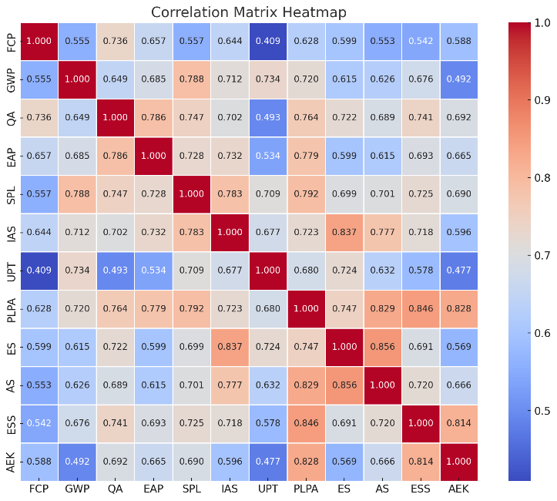
From Table 1) it can be explained that the overall average of the respondents’ opinions on the factors influencing the teaching and learning of English subjects using the Active 3Ps teaching method has a very high level average 4.05, standard deviation 0.84. Objective 2) To determine the relationship between variables that influence the structural equation model on the design and development of English teaching.
Figure 2 Correlation showing the relationship between the observed variables across 12 variables.

From Figure 2) from the correlation table (Sudjit, B. 2024, June), (Sudjit et al., 2023) showing the relationship between the observed variables in 12 variables, it can be concluded that the FCP (Frequency of Classroom Participation) variable has a significant positive relationship with many variables such as GWP (Group Work Participation), which indicates satisfaction from group work, QA (Question Asking). Quality to Greater Learning, EAP (Extracurricular Activity Participation) Participation in activities related to English subjects outside of class or academic participation, such as IAS (Individual Assessment Scores), UPT (Use of Personalized Technology Tools), PLPA (Personal Learning Plan Adjustment), and AEK (Application of English Knowledge), indicate that the promotion of English language development has a significant positive correlation with other factors.
In terms of GWP variables, there is satisfaction from group work that has a positive relationship with many other variables such as QA, EAP (Extracurricular Activity Participation), SPL (Satisfaction with Personalized Learning), where learners are satisfied with the evaluation of learning outcomes that are tailored to their own needs in learning English, making it possible to recognize satisfaction from group work which has a positive impact on the quality of learning and participation in teaching and learning more effectively. Personally, it can be observed that IAS and SPL are also shown to be related to factors relevant to learning quality and the development of students' potential in many aspects for future development.
Table 2, Figure 3) The results of the analysis of the structural equation model of English subjects with the Active 3Ps-based English language teaching in the confirmatory element (CFA) (Rogers, P. 2024) from the Structural Equation Model of the factors influencing the Structural Equation Model of English subjects with the Active 3Ps-based English language teaching as shown in Table 2, Figure 3.

Table 2 the conformance values of the measurement model

Index Value | Criterion | Static Value | Outcome
p-value | $≥$.05 | .070 | Qualified
Goodness of Fit Index: GFI | $≥$.95 | .992 | Qualified
Comparative Fit Index: CFI | $≥$.95 | .998 | Qualified
Root Mean Square Error of Approximation: RMSEA | $≤$.05 | .050 | Qualified
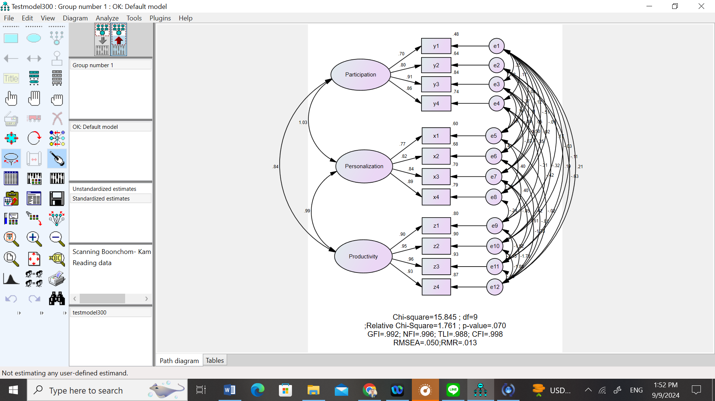

Figure 3 Structural Equation Model of English with Active 3Ps Teaching Model
From Figure 3) The table shows that the statistical significance level (p) has a static value of .070, which is above/higher than the specified threshold, so it is considered to have passed the benchmark. The Harmonized Level of Conformity Index value is static .992 above the given threshold, indicating that the model is consistent with empirical data. The Relative Harmonization Index has a static value of .998, which is higher than the specified threshold, indicating that the model is well consistent, and the square root index of the mean of estimated margin of error has a static value of .050, indicating that the model is very consistent. See Figure 4.
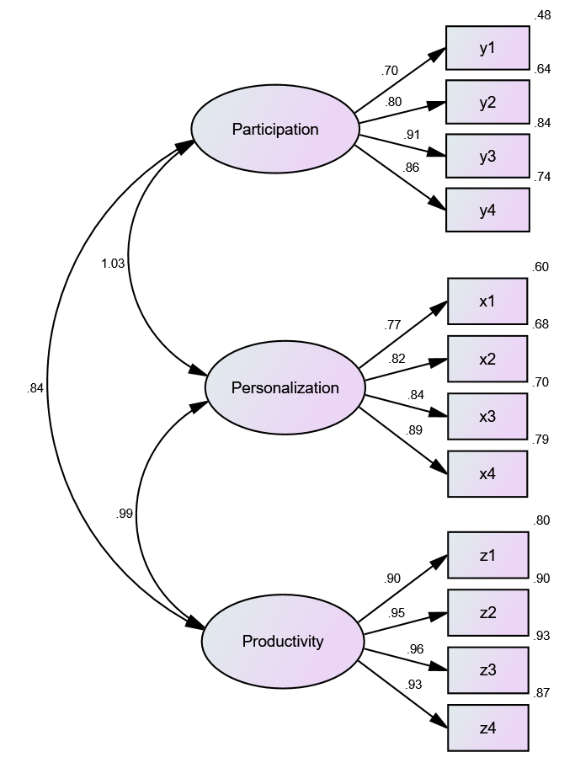
Figure 4 Structural Equation Model Analysis

Figure 4) The Structural Equation Model (Zhi, & Wang. 2023); (Sudjit, B. 2024. June). is an analysis of the Structural Equation Model, which shows the relationship between three latent variables: 1) Participation, 2) Personalization, and 3) Productivity and the variables observed in multiple variables (Y1-Y4, X1-X4, Z1-Z4). The results of the relationship analysis are detailed in Table 3.

Table 3 Transition markers

Latent Variables | Observable variable | Standardized Regression Weight Estimate | $$R^{2}$$
Participation | Y3  Y4  Y2 | .91  .86  .80 | .84  .74  .64
 | Y1 | .70 | .48
Personalization | X4  X3  X2 | .89  .84  .82 | .79  .70  .68
 | X1 | .77 | .60
Productivity | Z3  Z2  Z4 | .96  .95  .93 | .93  .90  .87
 | Z1 | .90 | .80

From Table 3) it can be concluded that in the Participation latent variable, there are 4 observable variables, namely Y1, Y2, Y3, and Y4, the factor loadings are in the range of .70 to .91, and the R² values of the variables Y1 to Y4 are in the range of .48 to .74 with path coefficient at 1.03.
Personalization includes observable variables: X1, X2, X3, and X4. The factor loadings are in the range of .77 to .89, while R² values of variables X1 to X4 are in the range of .60 to .79. Personalization correlates with productivity with a path value of .99.
Productivity has four observable variables: Z1, Z2, Z3, and Z4, factor loadings in the range of .90 to .96, and R² values for variables Z1 to Z4 in the range of .80 to .87. In addition, the correlation between Participation and Personalization was .84, indicating a high correlation between the two variables.

Conclusions
The study titled “An Analysis of the Structural Equation Modeling Influencing the Active Three Ps-Based English Language Teaching” employed Structural Equation Modeling to uncover key insights into various factors influencing English teaching and learning. The findings indicate that participation significantly and positively impacts the personalization latent variable, with a pathway value of 1.03. This suggests that increased participation enhances the ability to tailor English teaching and learning to individual needs. Additionally, the personalization variable which positively influences productivity has a path value of 0.99, indicating that personalized approaches in English learning also contribute to improved productivity. Moreover, the path value between the participation and personalization latent variables is 0.84, demonstrating a strong correlation between these two factors. This indicates that learner engagement fosters personalized learning experiences.
The factor loadings of the observable variables (Y1-Y4, X1-X4, Z1-Z4) ranged from .70 to .96, which showed that the latent variables in the three variables (Participation, Personalization, Productivity) were appropriately measured from the observed variables in this model.
Productivity Variable is most influenced by Personalization. The Productivity variable has very high factor loadings from the observable variables Z1-Z4, showing that personalization is a factor that greatly influences learners’ productivity.
In the R² section, it shows the explanatory capabilities of the model. The R² value of the observable variable ranges from .48to .87, which means that the model can explain the variance of the observable variable quite well.
Future research should aim to expand the sample size and include a diverse population to increase the ability to draw conclusions about the Active 3Ps teaching method. Additionally, exploring additional variables, such as student motivation and previous language proficiency, may provide even greater insights. Research studies comparing it with other teaching methods or integrating technology may increase the effectiveness of such methods even more. In addition, incorporating qualitative research methods, such as interviews and discussion groups may help us to better understand the experience.

References
Asfihana, R., Rafiqa, R., Iskandar, I., Rahayu, P. S., & Fuentes, A. S. (2024). The impact of virtual video project on students’ English learning engagement. LLT Journal: A Journal on Language and Language Teaching. 27(2): 613–631. https://doi.org/10.24071/llt.v27i2.6483
Baker, J., & Westrup, H. (2000). The English language teacher’s handbook: How to teach large classes with few resources. Continuum. https://pccambodiaprojects.wordpress.com/wp-content/uploads/2013/12/the-english-language-teacher_s-handbook.pdf
Brown, H. D. (2007). Principles of language learning and teaching. (5th ed.). Pearson Education. https://www.scirp.org/reference/referencespapers?referenceid=3672310
Cha, Q., & Yang, W. (2022, December). English writing teaching system based on computer-assisted language teaching. In 2022 International Conference on Knowledge Engineering and Communication Systems (ICKES). (pp. 1–6). IEEE. https://doi.org/10.1109/ICKECS56523.2022.10060346
Fiandini, M., Nandiyanto, A. B. D., Al Husaeni, D. F., Al Husaeni, D. N., & Mushiban, M. (2024). How to calculate statistics for significant difference test using SPSS: Understanding students comprehension on the concept of steam engines as power plant. Indonesian Journal of Science and Technology. 9(1): 45–108. https://doi.org/10.17509/ijost.v9i1.64035
Flores, R. A. (2024). Exploring Philippine English in student publications: Perspectives of English teachers on language usage and acceptance. LLT Journal: A Journal on Language and Language Teaching. 27(2): 632–647. https://doi.org/10.24071/llt.v27i2.7293
Hair Jr, J. F., Hult, G. T. M., Ringle, C. M., Sarstedt, M., Danks, N. P., & Ray, S. (2021). An introduction to structural equation modeling. In Partial least squares structural equation modeling (PLS-SEM) using R: a workbook. Cham: Springer International Publishing. https://link.springer.com/chapter/10.1007/978-3-030-80519-7_1
Hmimou, A., Iaousse, M., El Hadri, Z., Hmimou, S., Hachimi, H., & El Kettani, Y. (2021). Treatment of correlated errors in structural equation models. In Proceedings of the 7th International Conference on Optimization and Applications (ICOA). (pp. 1–5). https://doi.org/10.1109/ICOA49421.2020.9094528
Kline, R. B. (2023). Principles and practice of structural equation modeling. (4th ed.). Guilford Press. https://www.guilford.com/create-flyer/kline
Maitlo, S. K., Shah, S. A. A., & Ahmed, A. (2024). Use of information and communication technology (ICT) in teaching English as a second language (ESL). Journal of Arts and Linguistics Studies. 2(1): 27–51. https://jals.miard.org/index.php/jals/article/view/84
Namwong, O. (2011). Active 3Ps: The role of teaching management that teachers should change. Journal of Education Khonkaen University. 34(3–4): 1–9. https://so02.tci-haijo.org/index.php/EDKKUJ/ article/view/49871/41270 [in Thai]
Pachontarapak, B., Photaksin, N., & Mookmanee, N. (2021). English learning problems of Thai people. Journal of MCU Ubon Review. 6(3): 919. https://so06.tci-haijo.org/index.php/mcjou/article/ view/249630/170603 [in Thai]
Richards, J. C., & Rodgers, T. S. (2014). Approaches and methods in language teaching. Cambridge: Cambridge University Press. https://doi.org/10.1017/9781009024532
Rogers, P. (2024). Best practices for your confirmatory factor analysis: A JASP and lavaan tutorial. Behavior Research Methods. 56(7): 6634–6654. https://doi.org/10.3758/s13428-024-02375-7
Sudjit, B. (2024, June). Factors affecting structural equation modeling of discarded flowers using virtual reality technology: Articles. JSCI-SBU. 4(1): 42–54. https://ph02.tci-haijo.org/index.php/JSCI/ article/view/252376/170873
Sudjit, B., Sukvaree, T., & Praneetpolgrang, P. (2023). Factors affecting the design of process architecture for the development of applied graphic letter set based on the wisdom and identity of Thai alphabet art in 4 regions. Progress in Applied Science and Technology. 13(1): 33–40. https://doi.org/10.14456/past.2023.4
Tran, T. T. (2013). Factors affecting teaching and learning English in Vietnamese universities. The Internet Journal Language, Culture and Society. 38(1): 138–145. https://aaref.com.au/wp-ontent/ uploads/2018/05/38-16.-Thi-Tuyet-Tran-ok.pdf
Zhang, X. (2019, June). A study on the factors affecting the effectiveness of English hybrid teaching based on web platform. In 2019 International Conference on Robots & Intelligent System (ICRIS). (pp. 339–343). https://doi.org/10.1109/ICRIS.2019.00092
Zhi, R., & Wang, Y. (2023). English as a foreign language teachers’ professional success, loving pedagogy and creativity: A structural equation modeling approach. Thinking Skills and Creativity, 49, 101370. https://doi.org/10.1016/j.tsc.2023.101370

Teacher, Faculty of Engineering and Architecture, Rajamangala University of Technology Tawan-ok
Teacher Dr., Faculty of Engineering and Architecture, Rajamangala University of Technology Tawan-ok
Teacher, Faculty of Liberal Arts, Rajamangala University of Technology Tawan-ok

